MG3510 |  | Sports equipment Jumping ladder
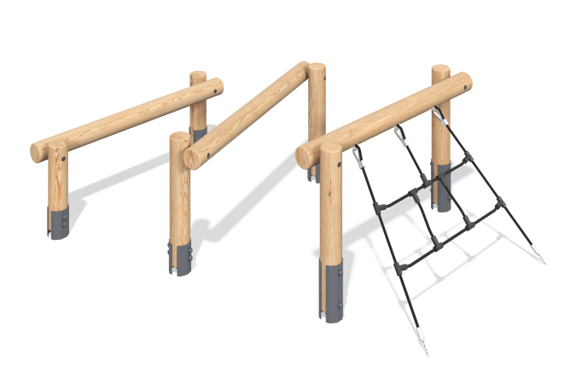

Size, mm: | 2490x3079x1055 | Weight, kg: | 0
Material characteristics
Materials: softwood - larch, metal, reinforced polypropylene rope, stainless steel.
Package includes: support post - 6 pcs., crossbars - 3 pcs., rope ladder - 1 pc., fastener kit - 1 pc.
The support posts are made of rounded larch timber with a diameter of 140 mm. The crossbars are also made of rounded larch timber with a diameter of 90 mm.
The sports equipment includes an inclined rope net made of six-strand reinforced polypropylene rope d = 16 mm.
The complex uses stainless steel fasteners. Protruding parts of threaded connections and open parts of pipes are covered with plastic plugs.
Coating of elements:
- metal - zinc powder primer, powder paint;
- timber - glazing primer, water-dispersion varnish.

