MG3509 |  | Sports equipment Log
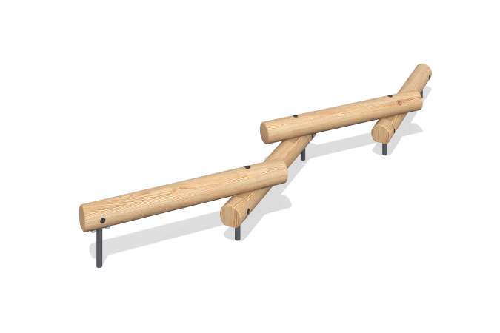

Size, mm: | 550x3500x370 | Weight, kg: | 0
Material characteristics
Materials: softwood, metal.
Package includes: 5 support posts, 4 climbing logs, 1 fastener kit.
The sports element is made of 5 support posts and climbing logs. The logs are made of rounded larch timber with a diameter of 140 mm.
The support posts are made of round metal tubing with a diameter of 33.5 mm and a wall thickness of 2.8 mm.
The set uses stainless steel fasteners. Protruding threaded connections and exposed pipe sections are covered with plastic plugs.
Finishing:
- Metal: zinc powder primer, powder paint;
- Timber: translucent primer, water-based varnish.

