MG3506 |  | Sport equipment
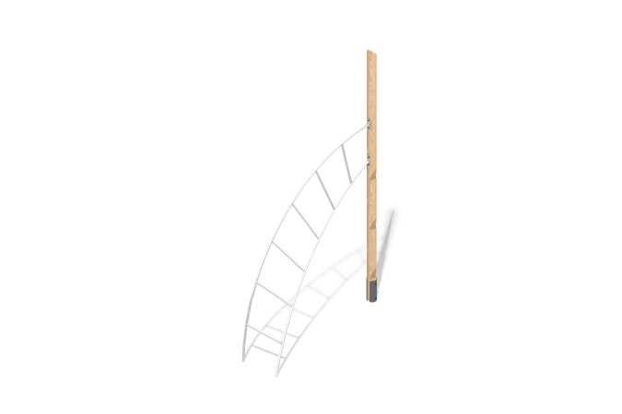

Size, mm: | 559x2268x3601 | Weight, kg: | 60.1464
Material characteristics
Materials: softwood (larch), stainless steel, metal.
Package includes: 1 support post, 1 arched ladder, 1 fastener kit.
The sports element consists of 1 support post and a climbing ladder. The support posts are made of rounded larch timber with a diameter of 140 mm.
The ladder is made of round stainless steel pipe with a diameter of 33.7 mm and a wall thickness of 3 mm.
The set uses stainless steel fasteners. Protruding threaded connections and exposed pipe sections are covered with plastic plugs.
Finishing:
- Metal: zinc powder primer, powder paint;
- Timber: translucent primer, water-based varnish.

