MG4207 |  | Sports system
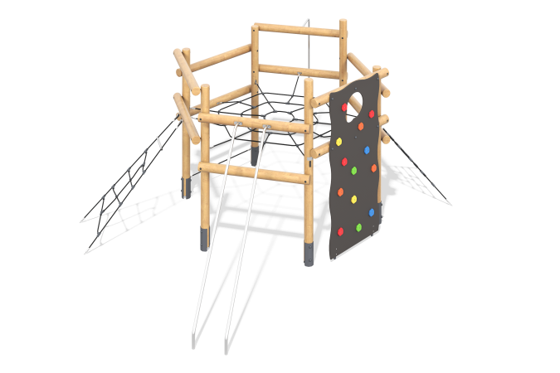

Size, mm: | 5344x6565x2805 | Weight, kg: | 485.79
Material characteristics
Materials: rounded larch timber, metal, stainless steel, laminated plywood, reinforced polypropylene rope.
Includes: frame of the complex - 1 set; rails - 1 set; horizontal net made of reinforced polypropylene rope - 1 pc; climbing net - 2 pcs; rope crossbar - 1 pc; fire escape - 1 pc; climbing wall - 1 pc; fasteners - 1 set.
The complex consists of 6 support posts and 12 horizontally positioned posts with a round diameter of 140 mm, made of rounded larch timber.
The fire escape and rails installed in the sections of the complex are made of round stainless steel tube with a diameter of 33.7 mm and a wall thickness of 2 mm.
The climbing wall is made of high-strength, moisture-resistant 21 mm thick plywood, to which climbing holds are attached. The complex features items and play elements made of reinforced polypropylene rope with a diameter of 16 mm, consisting of six strands, each strand reinforced with metal wire.
The equipment uses stainless steel fasteners. Protruding threaded connections and exposed pipe sections are covered with plastic plugs.
Finishing of the elements:
- Metal: zinc powder primer, powder paint;
- Timber: translucent primer, water-based varnish.

