34.304 |  | Anti-parking hemisphere
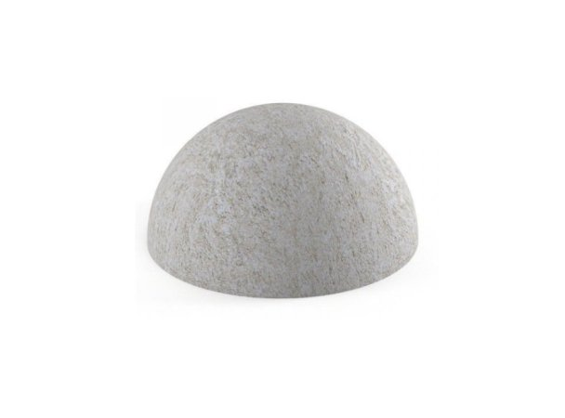

Size, mm: | 500x500x240 | Weight, kg: | 78
Material characteristics
Materials: concrete. Complete set: hemisphere - 1 pc.
Reduced-size concrete hemisphere. The size of the hemisphere with a diameter of 500 mm is suitable for installation on sidewalks along the road. This size of the hemisphere will prevent parallel parking of vehicles with a drive onto the curb.
At the bottom of the anti-parking hemisphere there is a reinforcement insert for fixing the fence on the installed surface. For installation, a hole is drilled and the hemisphere is fixed. For more reliable fixation, it is possible to use two-component glue by filling the drilled hole.

