MG1105 |  | Sandpit
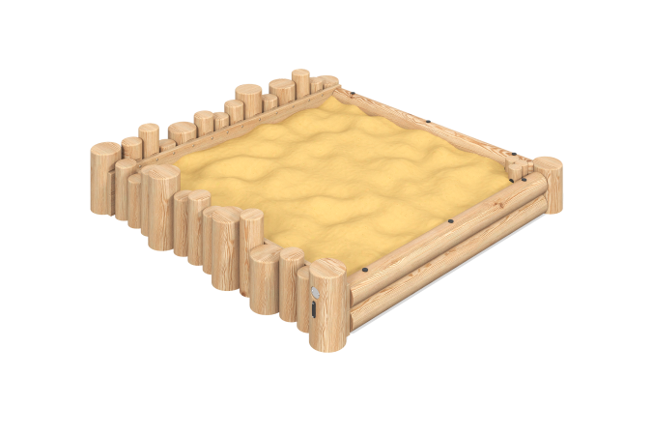

Size, mm: | 2256x2256x450 | Weight, kg: | 305.993
Material characteristics
reinforced polypropylene rope

