MG0515 |  | Swing
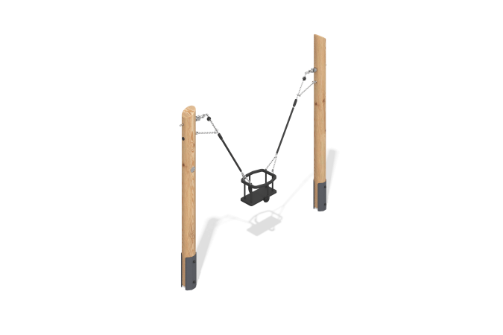

Size, mm: | 300x2050x2100 | Weight, kg: | 58.47
Material characteristics
Materials: rounded larch logs, metal, stainless steel.
Includes: 1 frame, 1 cradle seat, 1 mounting kit.
The swing consists of two round support posts. The posts are made of rounded larch logs and have a diameter of 140 mm. All posts are sanded. The treated surfaces are coated with tinted and clear varnish. The support posts are installed on anchor points.
The cradle seat is suspended from the swing using a short-link stainless steel chain. All parts are made of metal and coated with thermoplastic elastomer (TPE), a soft, flexible material.
The equipment uses stainless steel fasteners. Protruding threaded connections and exposed pipe sections are covered with plastic plugs.
Finish:
- Metal - zinc powder primer, powder paint;
- timber - glazing primer, water-dispersion varnish;

