MG0223 |  | Spring Rider Car
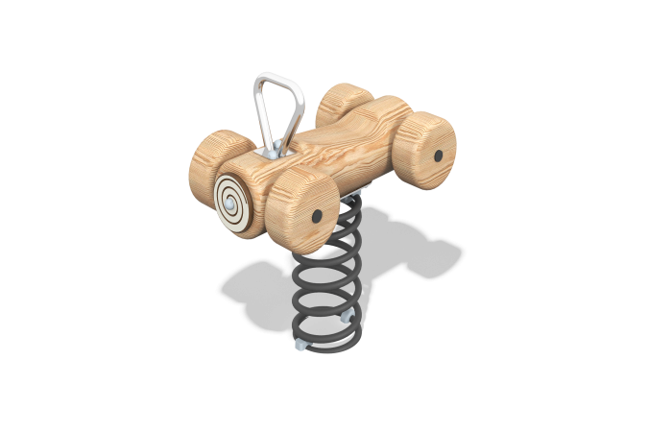

Size, mm: | 420x720x800 | Weight, kg: | 19.9418
Material characteristics
Main materials: softwood timber – Larch, HPL plastic, metal, stainless steel, stainless fasteners.
Package contents: Embedded parts - 1 pc. ; base with spring – 1 set, seat - 1 pc., Game element - 1 pc., handle - 1 pc., decorative element "Wheel" – 4 pcs., a set of fasteners - 1 pc.
The rocking chair consists of a seat made of softwood timber D 200 mm on a metal spring, the handles are made of a metal tube with a diameter of 25 mm. The decorative elements of the "wheel" are made of larch timber D 200 mm. The profile is round, the radius of the rounded corners is R10 and R20.
The game element is made of double-sided HPL plastic with a thickness of 14 mm.
The complex uses stainless steel fasteners. The protruding parts of the threaded connections and mounting holes are covered with plastic plugs.
Coating of the elements:
- metal - powder zinc grunt, powder paint;
- timber - lessening primer, water-dispersion varnish.

