34.105 |  | Park Table with Benches HPL
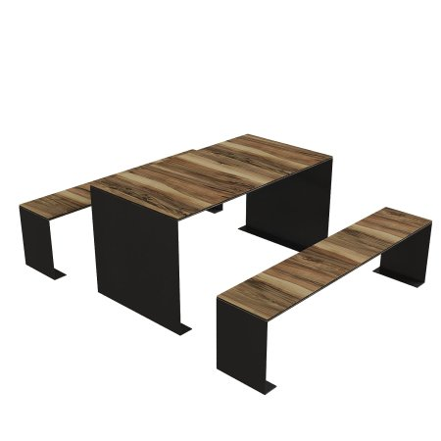

Size, mm: | 1500x1700x750 | Weight, kg: | 0
Material characteristics
Materials:
metal, plastic
Package includes:
Outdoor table – 1 pc., outdoor bench – 2 pcs.
The frame of the tabletop and benches is made of galvanized sheet metal 4 mm thick with a powder coating that provides protection against corrosion. The surfaces are made of HPL plastic 12 mm thick with a UF coating that is resistant to ultraviolet radiation and precipitation. The dimensions of the table are 1500×790×750 mm, benches - 1500×350×400 mm.

