19.154 |  | Sandpit 1500x1500
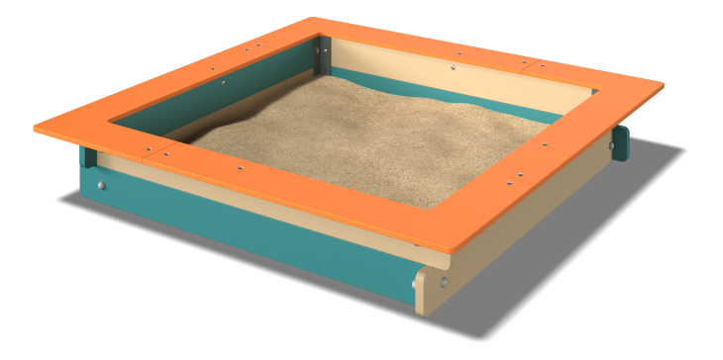

Size, mm: | 1500x1500x250 | Weight, kg: | 33.35
Material characteristics
Materials:
-Plywood 24 mm thick.
-Plywood 15 mm thick.
-Powder paint.
-Water based paint.
The product is a game element consisting of side walls made of 24mm thick plywood, seats made of 15mm thick plywood and mounting embedded parts made of 40x40mm steel profile corners. with a wall thickness of 4mm. The side walls are mated with embedded corners using galvanized steel fasteners, the seats are attached to the walls using plastic and steel corners, all bolted connections are closed with plastic decorative plugs.
Equipment:
-Mounting corner 4 pcs.,
-Upper wall 4 pcs.,
-Bottom wall 4 pcs.,
-Seat 4 pcs.
-Set of fasteners and plugs 1 pc.

