17.014 |  | Steel Swing Frame Nest
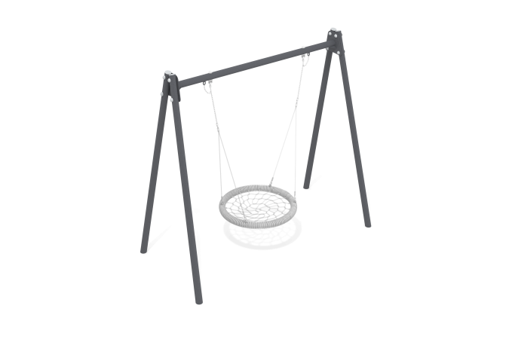

Size, mm: | 1460x2980x2640 | Weight, kg: | 120
Material characteristics
The frame is a structure consisting of 4 supports made of metal round pipes and 1 crossbar fixed between them. Round pipes with a diameter of 89mm and a wall thickness of 3mm.
Metal painting is done with polymer paint. All open parts of pipes and bolted connections are closed with plastic plugs.
Frame elements:
Support post – 4 pcs.
Crossbar – 1 pc.
Hanging fasteners – 2 sets.
Fastening kit – 1 pc.
Plug 89 mm - 4 pcs.

