39.040 |  | Waste container enclosure (5 containers)
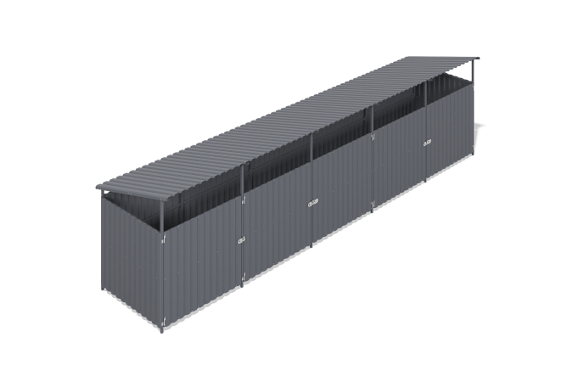

Size, mm: | 1960x8000x2200 | Weight, kg: | 277.16
Material characteristics
Materials: metal.
Complete set: side sections - 2 pcs., intermediate sections - 4 pcs., frame cross-members - 30 pcs., welded doors - 5 pcs., embedded parts - 12 pcs., profiled sheet 1500 mm long - 19 pcs., profiled sheet 2000 mm long - 9 pcs.
A five-section container platform with doors is designed to accommodate containers and protect them from rain and other weather conditions. The frame consists of welded wall panels, lintels, and doors made of 40x40 mm and 40x20 mm profile pipes with a wall thickness of 2 mm, as well as flanges and plastic elements. All metal parts are shot-blasted, cleaned, degreased, and painted with powder coating. The cladding is made of galvanized profiled sheet C20 with a polymer coating, secured with roofing screws with press washers.

