34.265 |  | Topiary Giraffe on a bike
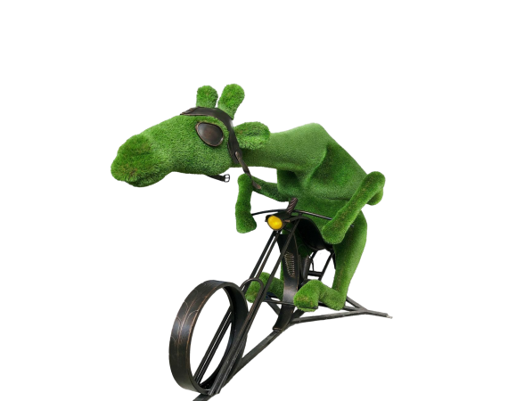

Size, mm: | 2150x3800x1700 | Weight, kg: | 0
Material characteristics
Material: fiberglass,
artificial turf.
Included: topiary - 1 pc.

