37.014 |  | Play System Science (stainless steel slide)
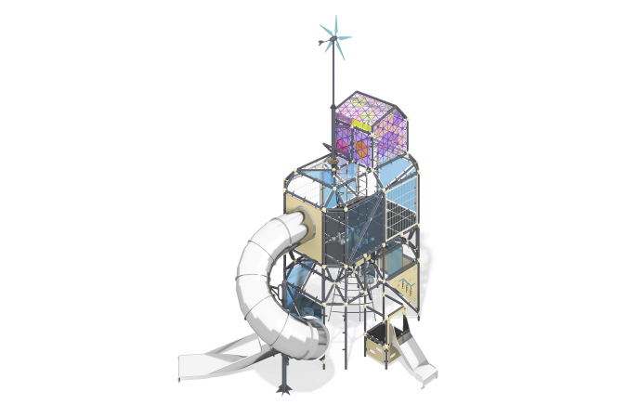

Size, mm: | 4802x5848x7830 | Weight, kg: | 2156.665
Material characteristics
The frame of the complex consists of conventional parallelepipeds with cut corners, the edges of which are metal pipes. The modules are connected by rope ladders and passages. The entrances of the complex are designed in the form of rope ladders, rope nets, and free areas between frame elements. The floors are made of laminated plywood with an anti-slip coating. The complex has two stainless steel slides: an open straight one and a spiral tunnel one.
The frame of the complex is made of round metal pipes connected using metal Markhi nodes. Enclosing and interactive panels of the complex are made of monolithic polycarbonate with color coating, HPL plastic, metal mesh.
A metal stand with a windmill is installed on the roof of the complex. Game elements of the complex: module “Perpetual Calendar”, game installations on metal stands “Billiards” and “Gate”, height meter, panel with sliders.
Materials: metal, laminated plywood, HPL plastic, monolithic polycarbonate, reinforced polypropylene rope, stainless steel.

