30.073 |  | Tennis table
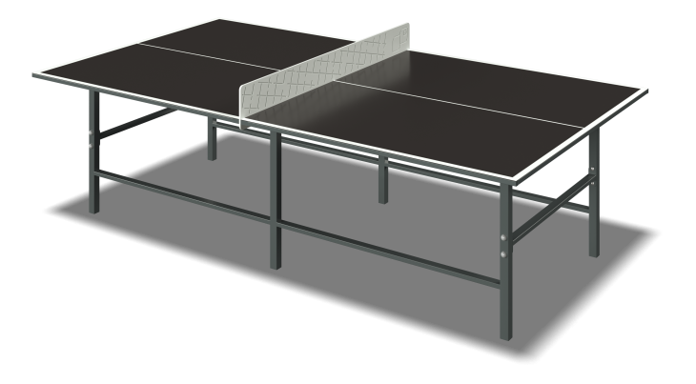

Size, mm: | 1470x2740x910 | Weight, kg: | 87.63
Material characteristics
Materials: moisture-resistant birch plywood, moisture-resistant laminated plywood, metal, acrylic paint, powder paint.
The table is mounted on six load-bearing supports made of a square metal pipe with a cross-section of 40 mm x 40 mm and a wall thickness of 2 mm.
The frame is made of metal profile pipes with a cross-section of 40 mm x 40 mm with a wall thickness of 2 mm and metal profile pipes with a cross-section of 40 mm x 20 mm with a wall thickness of 2 mm. The connection of metal structural elements is carried out using bolted connections through fastening plates.
The tabletop is made of high-strength, moisture-resistant laminated plywood 15 mm thick. The decorative element “mesh” is made of high-strength, moisture-resistant plywood 15 mm thick.
Plywood elements are attached to the metal frame using fasteners.
The protruding parts of the threaded connections are closed with plastic plugs. All existing metal parts are painted with polyester powder paint.
Contents: Sidewalls – 2 pcs. Cross members - 5 pcs. Decorative element “mesh” - 1 pc. Table top - 2 pcs. Fastening kit - 1 pc.

