37.010 |  | Coastal Lighthouse
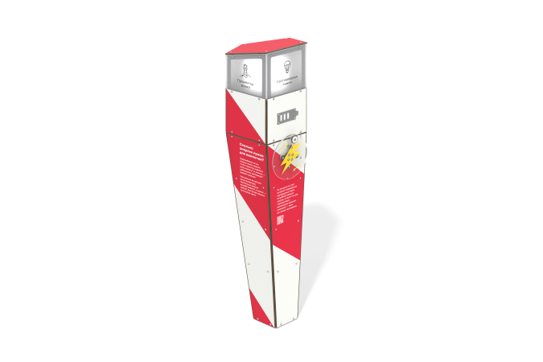

Size, mm: | 534x566x1771 | Weight, kg: | 82.783
Material characteristics
Educational game module.
The module is a structure made from a generator set with light bulbs located inside a housing made of HPL plastic with windows made of monolithic polycarbonate. On the side of the case there is a round disk made of monolithic polycarbonate with a handle and a charge indicator in the form of a battery. When the handle is rotated, the generator is charged and the lights inside the installation alternately turn on, simulating the operation of a beacon.
Materials: metal, HPL plastic, monolithic polycarbonate.

