37.001 |  | Scientific module Morse code
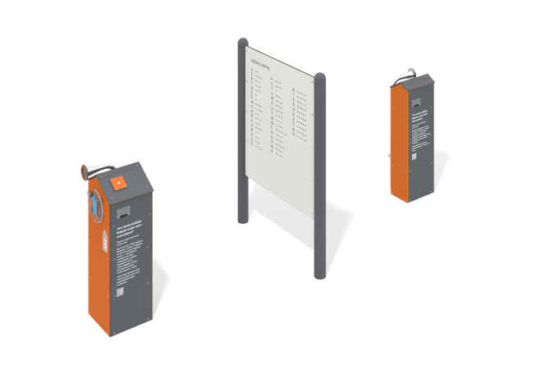

Size, mm: | 1326x4000x1828 | Weight, kg: | 255.471
Material characteristics
Educational game module.
The product is a structure consisting of a device with a generator set, transmitting a Morse code signal and an intercom with two bells. The electronic components of the device are housed inside two HPL plastic housings. On one body there is a button for transmitting a signal, a charge indicator in the form of a battery, a rotating panel made of monolithic polycarbonate with a handle, the rotation of which charges the generator. On the other body there is a speaker that allows you to receive the signal. Between the device housings there is a shield made of HPL plastic on metal stands. Letters of the Russian alphabet are applied to the shield on both sides, which are compared with Morse code, which allows messages to be transmitted and decrypted. An intercom pipe passes between the housings of the device and is recessed into the base. The sockets are fixed to the housings.
Materials: HPL plastic, metal, stainless steel.

