30.020 |  | Sports Module Basketball hoop
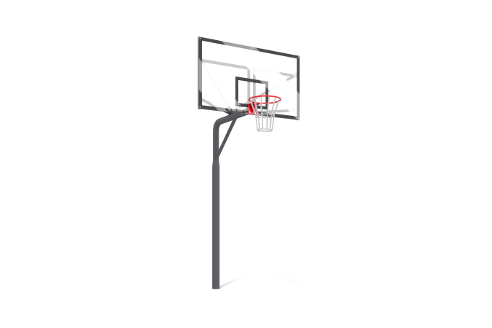

Size, mm: | 1800x2000x3900 | Weight, kg: | 109.965
Material characteristics
Materials: Metal, powder paint, monolithic polycarbonate, anti-vandal basketball hoop.
The basketball stand is made of a steel pipe with a diameter of 133 mm with a wall thickness of 4.5 mm, turning into a steel pipe with a diameter of 108 mm and a wall thickness of 3 mm. A frame made of a steel profile pipe 40 mm x 20 mm with a wall thickness of 2 mm is attached to the stand through a flange.
A basketball backboard made of transparent monolithic polycarbonate 10 mm thick is installed on the frame using bolts. Markings are applied to the shield.
The basketball hoop is secured to the frame with bolts passing through the backboard.
To impart rigidity to the structure, the frame is secured with ties made from a steel profile pipe 40 mm x 20 mm with a wall thickness of 2 mm.
All fasteners are galvanized. All existing metal parts are painted with polyester powder paint.
Contents: Stand - 1 pc., Backboard frame - 1 pc., Backboard - 1 pc., Anti-vandal basketball hoop - 1 pc., Fastening kit - 1 pc.

