30.091 |  | Concrete tennis table
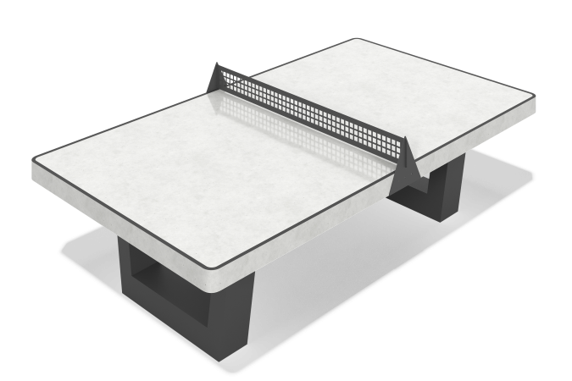

Size, mm: | 1525x2740x760 | Weight, kg: | 1430
Material characteristics
Materials: concrete, metal.
Complete set: tennis table – 1 pc.
The tennis table has a stable and durable design, designed for long-term use in various climatic conditions. Frost resistance grade: F 150. Composition: natural stone of 5-10 mm fraction as a filler, reinforcement frame. Front surface: glossy, polished with a visible structure of natural stone.

