17.111 |  | Triple swing
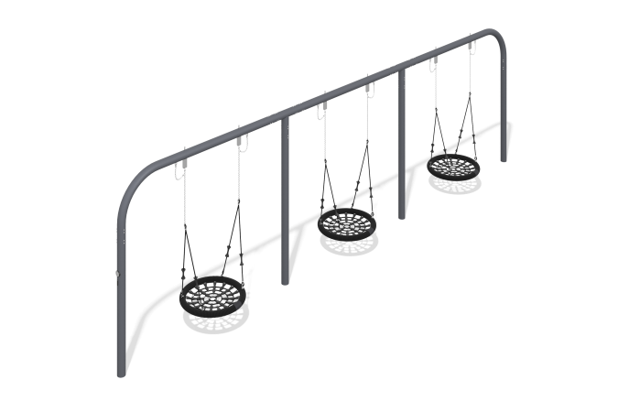

Size, mm: | 1000x10100x3000 | Weight, kg: | 468.826
Material characteristics
Material: metal, stainless steel, rope.
Contents: swing frame - 1 pc., "nest" suspension - 3 pcs., fastening kit - 1 pc.
The swing consists of one full frame made from a round pipe with a diameter of 133 mm and a wall thickness of 4.5 mm.
The rim of the “nest” suspension is made of a metal pipe, the weaving inside the ring is made of reinforced four-strand rope with a diameter of 16 mm. The polyester found in braided rope is UV resistant. Each strand is reinforced with metal wires.
The suspension is attached to the swing using stainless steel slings. The slings are attached to the support crossbar using a bearing unit with a rolling mechanism, through a chain made of stainless steel.
The equipment uses stainless steel fasteners. The protruding parts of threaded connections and open parts of pipes are closed with plastic plugs.
Element coverage:
- metal - powder zinc primer, powder paint;

