23.031 |  | Educational Module Xylophone Illusion
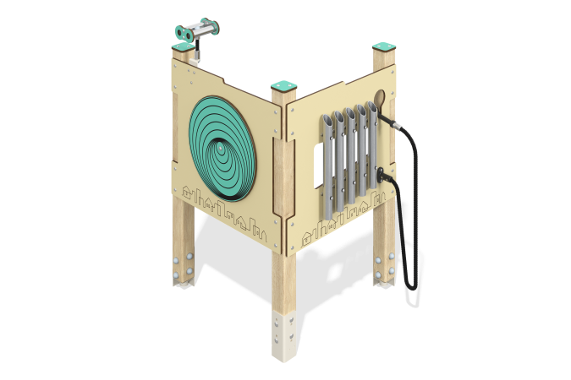

Size, mm: | 820x830x1300 | Weight, kg: | 35.764
Material characteristics
Material: softwood timber, HPL plastic, monolithic polycarbonate, stainless steel, reinforced polypropylene rope, stainless fasteners.
Contents: embedded parts – 1 set, support posts – 3 pcs., “Illusion” panel – 1 pc., binoculars – 1 pc., rope – 1 pc., hammer – 1 pc., “Xylophone” panel – 1 pc., fastening set – 1 pc.
Design and color palette of equipment according to the sketch.
The educational element consists of three supports made of laminated veneer lumber, on which are mounted the “Illusion” game panel with rotating circles on both sides of the panel and the “Xylophone” game panel with stainless steel tubes and a plastic handle secured with a polypropylene rope. The support posts are made of laminated coniferous timber with a cross-section of 80x80 mm. The profile is square, the corner radius is R10.
The “Illusion” game element is made of double-sided HPL plastic with UV protection, 10 mm thick. Drawings are applied to the panels using engraving and UV printing. The binoculars are mounted on a “hinge” consisting of polypropylene reinforced rope. The binoculars consist of a stainless steel pipe with a diameter of 33.7 mm and a wall thickness of 2 mm, and stainless steel sheets with a thickness of 3 mm. The binocular glasses are made of monolithic polycarbonate, on top of which decorative covers made of HPL plastic 10 mm thick are installed.
The Xylophone gaming element is made of double-sided HPL plastic with UV protection, 10 mm thick. Drawings are applied to the panels using engraving. The xylophone pipes are made of stainless steel pipes with a diameter of 42.4 mm and a wall thickness of 2 mm, and stainless steel sheets with a thickness of 3 mm. A plastic handle 150 mm long is attached to a reinforced rope 800 mm long.
Caps made of HPL plastic with UV protection 10 mm thick are installed on the upper part of the support posts. The gaming panel uses stainless steel fasteners. Protruding parts of threaded connections and open parts of pipes are closed with plastic plugs.
The purpose of the game “Illusion”: on both sides of the panel there are circles, when rotated, optical illusions are created.
Purpose of the game “Xylophone”: you need to remove the handle from the panel and move it along the pipes on the panel. This action produces sound. The strength and nature of the blow affect how it will sound - quiet or loud, sharp or soft.
Element coverage:
- metal - powder zinc primer, powder paint;
- timber - glazing primer, water-dispersion varnish.

