35.027 |  | Low barrier for dogs
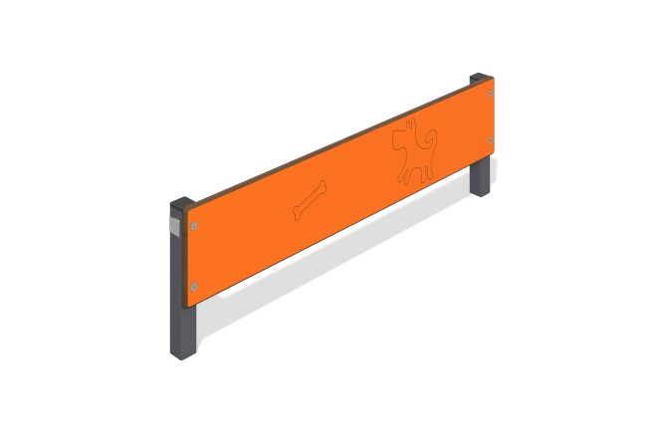

Size, mm: | 55x1000x323 | Weight, kg: | 6.4
Material characteristics
Materials: Metal, HPL plastic
The dog park low barrier consists of two 40mm x 40mm square steel tubes, 2mm thick, with 14mm thick HPL plastic attached to them. The plastic is decorated with thematic designs applied with a milling cutter. The product is coated with polymer paint. All open parts of the pipes are closed with plastic plugs 40 mm x 40 mm.
Contents: Stands - 2 pcs., shield - 1 pc., fastening set - 1 pc.

