30.118 |  | Side turnstile
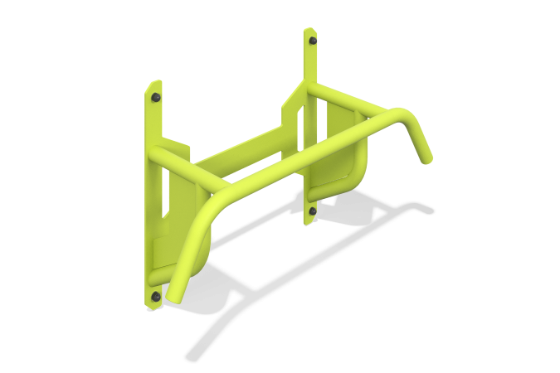

Size, mm: | 350x1060x2096 | Weight, kg: | 18.3329
Material characteristics
Materials: Metal
The horizontal bar element is a workout equipment. The structure consists of a frame of metal pipes with a cross-section of 42.3 x 2.8 mm and a metal sheet with a thickness of 4 mm and 8 mm. The ends of the pipes are covered with plastic plugs. The product uses stainless steel fasteners.
Package contents: turnstile frame, mounting kit - 1 pc.

