28.049 |  | Sports and Play System Quest
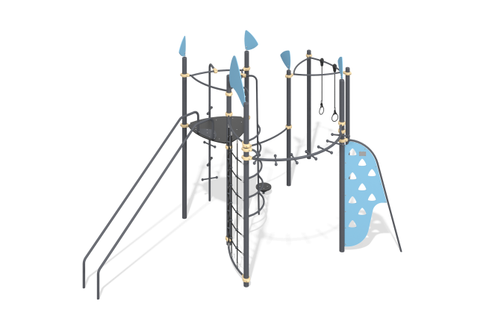

Size, mm: | 3844x6076x3549 | Weight, kg: | 364.56
Material characteristics
Designed to develop all muscle groups and perform functional training.
Materials: 18 mm plywood - surface of the platform, twister; Structural steel - pipe 89x4 (Racks), DN20x2.5 (staircase, rise, guide rail, support lintel), DN25x2.8 (staircase, platform frame, handrail, platform with rings, rope ladder rungs), DN32x2.8 (lift, rail descent, guide rail, support), Angle 45*45*4 (mortgage twister), Sheet 2/3/4/5/6 - fastening elements in the form of brackets, angles, flanges, connecting plates. General purpose plywood (thickness 15/18 mm), arch, flags, climber rise; reinforced rope EK f16mm - vertical mesh for climbing.
Complete set: Mortgages -5 pcs. (racks) and 1 pc. rail descent mortgage; racks (support pillars) - 5 pcs. high, 3 pcs. average; platforms: 3 pcs., 2 pcs. - consisting only of a triangular frame, one of which has gymnastic rings and one with a plywood surface; rise with spirally arranged steps; metal staircase; rail descent; monkey bars; climber's ascent; twister; vertical rope mesh - 1 piece; product passport (including assembly diagrams) - 1 pc.
Stand beam Racks pipe 89x4; External powder paint coating (polyester). The stand is covered with a metal cap.
Tower platforms: Platforms - 18 mm plywood, moisture resistant, with anti-slip laminated layer; platform frame - metal pipe DN25x2.8. Triangular profile platforms. 3pcs., 2pcs. - consisting only of a triangular frame, one of which has gymnastic rings and one with a plywood surface;
Coating of elements: Polymer coating of metal; two-layer coating of plywood - primer, acrylic paint (plywood - coating of ends and grooves). On the game panels - silk-screen printing.
Galvanized hardware. Protective caps M8 (Ф30 mm), М10-12 (Ф48 mm).

