38.079 |  | Shade canopy
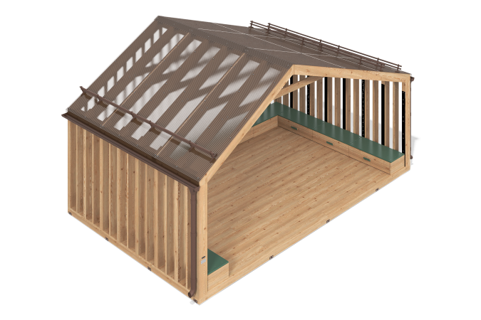

Size, mm: | 4222x7010x3654 | Weight, kg: | 3342.7029
Material characteristics
Main materials: softwood timber, planed softwood board, monolithic polycarbonate, FSF plywood, furniture shield, metal, stainless fasteners.
Package contents: embedded parts – 20 pcs.; side support posts – 30 pcs.; rear support posts – 23 pcs.; enclosing walls made of monolithic polycarbonate – 3 pcs.; gable roof made of monolithic polycarbonate – 1 pc.; ridge bar – 2 pcs.; cornice bar – 4 pcs.; snow holders – 5 pcs.; drainage system – 2 pcs.; rafter linings – 28 pcs.; wooden benches – 3 pcs.; wooden drawers – 9 pcs.; a set of fasteners – 1 pc.
The equipment consists of a house with a gable roof. The support posts are made of: glued rounded pine timber 100x200 mm – 16 pcs.; planed pine board 190x45 – 14 pcs.; planed pine board 90x45 – 23 pcs. The floor covering frame consists of: glued rounded pine timber 100x200 mm – 2 pcs.; glued rounded pine timber 100x100 mm – 11 pcs.; glued rounded pine timber 80x80 mm – 21 pcs.; planed pine timber 50x50 mm – 33 pcs. The connection is made due to reinforced corners: 90x65x65 – 132 pcs.; 90x40x40 – 132 pcs. and stainless fasteners. The floor covering consists of: planed larch boards 35x190 – 52 pcs.; planed larch boards 35x140 – 3 pcs. The side posts are connected by an upper mauerlat - glued cylindrical pine timber 100x200 mm – 2 pcs. The posts are connected to the beams by means of wooden beech sheets with diameters of 15 and 25 mm with the addition of carpentry glue. The walls of the house are made of transparent monolithic polycarbonate 5 mm thick. In the corners, the connection takes place due to a transparent polycarbonate corner profile and sealant. All polycarbonate fastening to wood takes place through thermal washers. The house consists of a gable roof with different angles of inclination: 29 and 18 degrees. The roof consists of: rafter legs made of glued rounded pine timber 100x200 mm – 16 pcs.; puffs made of planed pine board 45x140 – 6 pcs.; ridge made of glued rounded pine timber 100x200 mm – 1 pc.; facade linings made of furniture board 40 mm thick – 2 pcs.; spacer bars made of glued rounded pine timber 100x200 mm – 14 pieces and linings to the rafter legs from a furniture board 40 mm thick – 28 pieces. The connection is made by reinforced corners: 90x65x65 – 84 pcs.; 35x50x50 – 56 pieces, stainless fasteners and stainless studs. The roof covering is a monolithic polycarbonate in the color gray bronze with a thickness of 5 mm. The parts of monolithic polycarbonate are interconnected through connecting transparent profiles and sealant. The roof top is covered with a ridge bar – 2 pcs. Along the edges of the monolithic polycarbonate overhang, cornice strips are installed – 4 pcs. A drainage system is installed under the eaves. It consists of: gutter – 3 pcs.; gutter plug – 4 pcs.; gutter connector – 2 pcs.; hooks – 24 pcs.; funnel – 2 pcs.; bracket – 6 pcs.; round pipe – 2 pcs.; drain elbow – 2 pcs. Snow holders are installed on the roof – 5 pcs. Inside the house there are three benches along the edges, which consist of: planed pine boards 35x90, glued rounded pine timber 80x80 mm, plywood 24 mm thick. Inside the benches there are wooden drawers – 6 pcs. The drawers consist of: planed pine boards 35x90, planed pine timber 50x50 mm, plywood 12 mm thick, furniture board 20 mm thick, wheel support – 54 pcs.
The equipment uses stainless steel fasteners. The protruding parts of the threaded connections are covered with plastic plugs.
Coating of the elements: metal – powder zinc grunt, powder paint, timber – lessening and antiseptic primer, water-dispersion varnish, plywood – acrylic primer, acrylic enamel, water-dispersion varnish.

