30.085 |  | Volleyball stands with net
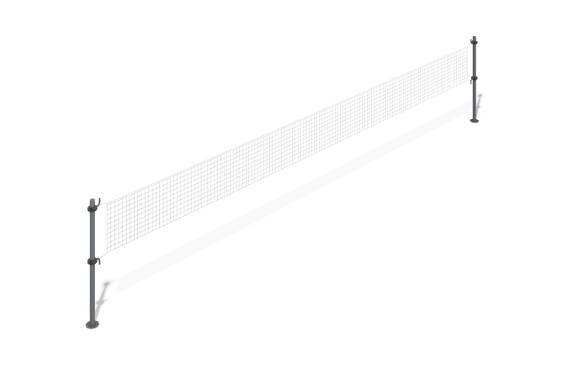

Size, mm: | 280x14280x2630 | Weight, kg: | 133.70548
Material characteristics
Materials: metal, nylon mesh.
Complete set: Post - 2 pcs., Hook - 4 pcs., Net - 1 pc., Fastener kit - 1 pc.
Equipment design and color palette according to the sketch.
Volleyball posts consist of two support posts. The posts are made of a round metal pipe with a diameter of 108 mm and a wall thickness of 3 mm. The hooks for the net are made of a round metal pipe with a diameter of 33.5 mm and a wall thickness of 2.8 mm. The hooks are attached to the support posts using clamps made of plastic.
The complex uses stainless steel fasteners. The protruding parts of the threaded connections and the open parts of the pipes are covered with plastic plugs.
Coating of the elements:
- metal - powder zinc primer, powder paint.

