39.126 |  | The Facets of the Future urn
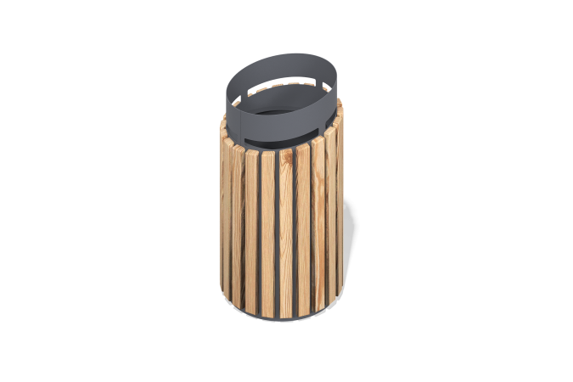

Size, mm: | 400x400x700 | Weight, kg: | 0
Material characteristics
Materials: metal, wood, powder primer, powder paint, oil impregnation.
The urn is a welded metal frame with boards mounted on it.
The metal frame consists of 2 mm thick sheet metal.
The lining of the urn is presented in the form of a 40 mm wide larch board with a thickness of 20 mm.
The metal frame is covered in 2 layers. 1 layer is powder primer, 2 layers are powder paint. The boards are impregnated with oil in 2 layers. The boards are fixed with structural self-tapping screws yellow zinc M4x19.
The inner garbage insert is made of galvanized sheet steel 0.5mm thick.
Equipment:
Urn assembly – 1 piece

