28.048 |  | Sports complex with rings
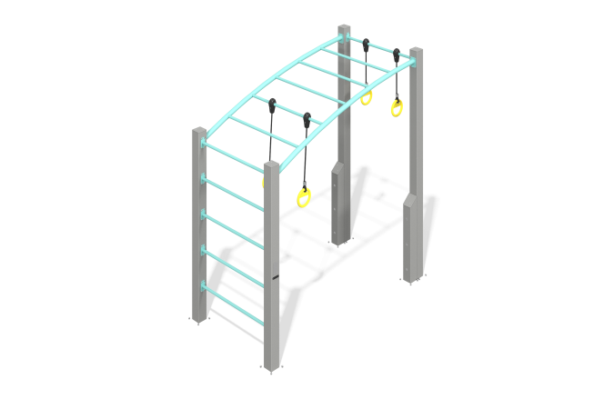

Size, mm: | 1300x2547x2736 | Weight, kg: | 196.617
Material characteristics
Materials: metal, reinforced rope.
Contents: support posts – 4 pcs., ladder – 1 pc., handlebar – 1 pc., rings – 4 pcs., fastening kit – 1 pc.
The complex consists of four support pillars made of a metal pipe 120x120 mm with a wall thickness of 3 mm, a ladder and a monkey bars made of a round metal pipe with a diameter of 33.5 mm and a wall thickness of 2.8 mm. The rings are made of a metal pipe with a diameter of 30 mm and a wall thickness of 2 mm. The rings are attached using reinforced rope with a diameter of 16 mm. The upper part of the pillars is closed with a 5 mm thick stainless steel plug.
The complex uses stainless steel fasteners. The protruding parts of threaded connections and open parts of pipes are closed with plastic plugs.
Element coverage:
- metal - powder zinc primer, powder paint.

