17.044 |  | Swing Spiral
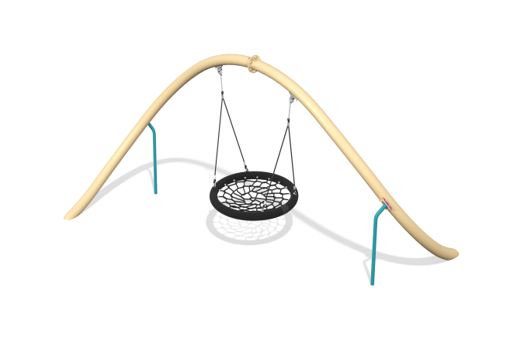

Size, mm: | 2942x4065x2220 | Weight, kg: | 170.197
Material characteristics
General description of the design
The product is a set of a composite spiral-shaped frame of the “Nest” suspension, attached to this frame.
Materials and components
Powder-painted steel with a layer of zinc-containing primer, plastic, stainless steel fasteners. The swing includes a “Nest” suspension.
Metal parts are coated in two layers: as the first layer, a powder zinc-containing primer is applied, which is a powder mixture based on epoxy resin, zinc and targeted additives, and polymerized in a high-temperature chamber. As a finishing layer, polyester powder paint is applied, which is a homogenized powder mixture of polyester resin, hardeners, pigments, fillers and modifiers selected to ensure weather resistance and light resistance. The finishing layer is polymerized in a high-temperature chamber.
Frame
It consists of two bent pipes with a diameter of 108 mm and a wall thickness of 3 mm, connected to each other through a flange at the top point of the product, and visually forming a spiral coil in the connected state. The structure of two thick pipes has additional supports attached to it through clamps and with the embedded part going underground.

