30.039 |  | Sports Module Axel
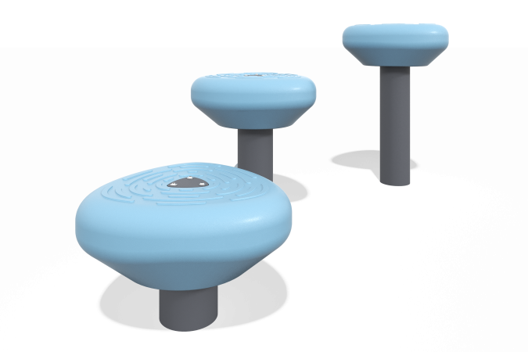

Size, mm: | 629x1482x580 | Weight, kg: | 28.21
Material characteristics
Materials: Metal, HDPE plastic.
Contents: support - 3 pcs.; ledges - 3 pcs.;
The pipe support is made of a metal round pipe with a diameter of 108 mm and a wall thickness of 3 mm. The ledges are made of plastic.
The complex uses stainless steel fasteners.
Element coverage:
- metal - powder zinc primer, powder paint.

