34.198 |  | Picnic table
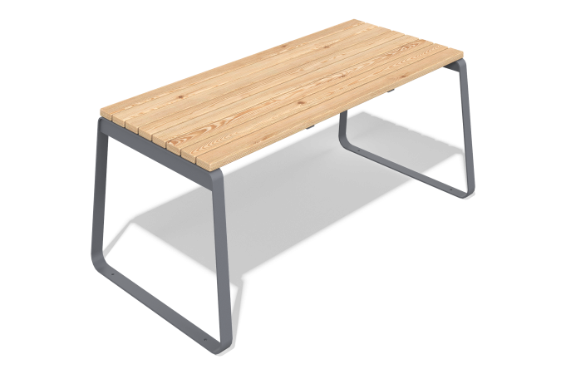

Size, mm: | 800x1800x760 | Weight, kg: | 66
Material characteristics
Materials: metal, larch, lacquer.
Package contents: table - 1 pc.
The table is a welded metal frame made of profile pipes with wooden boards fixed on it. The frame is painted with weather-resistant powder paint, and the wooden elements are coated with a protective varnish that is resistant to moisture and ultraviolet radiation. All fasteners are galvanized.

