16.047 |  | Spring Rider Cat with a ball
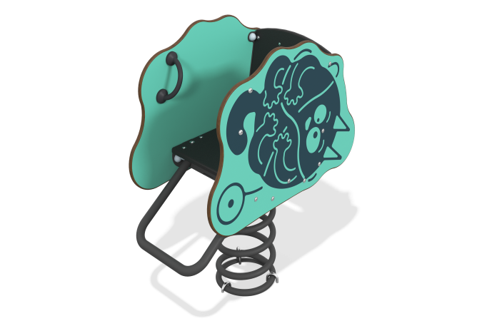

Size, mm: | 380x717x890 | Weight, kg: | 45.684
Material characteristics
Main materials: laminated plywood with anti-slip coating, HPL plastic, metal, stainless fasteners.
Contents: base with spring – 1 set, rocking chair sides – 2 pcs., seat – 1 pc., backrest – 1 pc., crossbar – 1 pc., handles – 2 pcs., fastening kit – 1 pc.
Design and color palette of equipment according to the sketch.
A rocking chair on a metal spring with two side panels made of HPL plastic 14 mm thick, a seat and back made of moisture-resistant laminated plywood 18 mm thick, a leg bar made of a round pipe with a diameter of 26.8 mm and a wall thickness of 2.8 mm. The spring is made of metal, dimensions 360x200x20 mm. The panels have plastic handles. Decorative elements and designs are applied using UV printing. On the front side of the panel there is a “Cat with a Ball” print.
The complex uses stainless steel fasteners.
Element coverage:
- metal - powder zinc primer, powder paint.

