17.027 |  | Rope Seat Nest With Plastic Handles
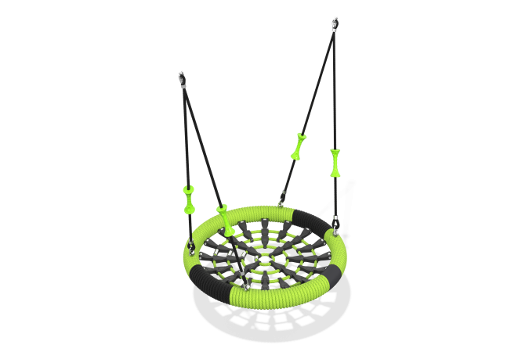

Size, mm: | 1078x1078 | Weight, kg: | 6
Material characteristics
Materials: metal, rope
Package includes: nest hanger - 1 pc., fastener kit - 1 pc.
The design consists of:
The seat rim is a steel pipe wrapped in a 3-strand unreinforced rope with a diameter of 19 mm. The weaving inside the ring is made of a 6-strand rope with a diameter of 16 mm, which is secured together with polyamide connectors, with a ribbed anti-slip coating. The hangers consist of a 4-strand rope of 16 mm. Equipped with plastic handles.
The design is reliable and designed for intensive use. It is intended for installation on outdoor playgrounds.
Protruding parts of threaded connections and open parts of pipes are covered with plastic plugs
Coating of elements: metal - powder zinc primer, powder paint.

