19.132 |  | Sandpit Preschooler
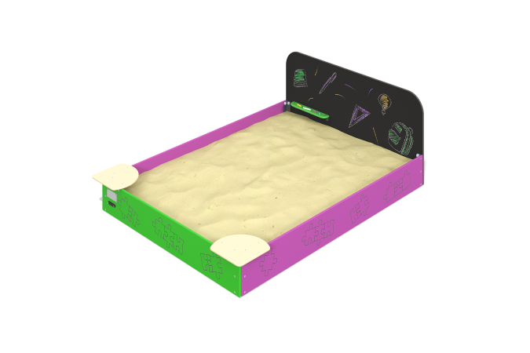

Size, mm: | 1600x2050x700 | Weight, kg: | 29.806
Material characteristics
Materials:
- Laminated plywood 15 mm thick.
-Plywood 15 mm thick.
-Powder paint.
-Water based paint.
The product is a game element consisting of side walls made of 15 mm thick plywood, seats made of 15 mm thick plywood, mounting embedded parts made of 40x40 profile corners with a wall thickness of 4 mm. The side walls are mated with embedded galvanized steel fasteners, the seats are attached to the walls using steel corners, all bolted connections are closed with plastic decorative plugs.
Equipment:
-Mounting corner 4 pcs.,
-Front wall 1 pc.,
-Board 2 pcs.,
- Rear wall 1 pc.,
-Seat 2 pcs.,
- Shelf 1 pc.,
-Set of fasteners and plugs 1 pc.

