19.120 |  | Sandpit with slide
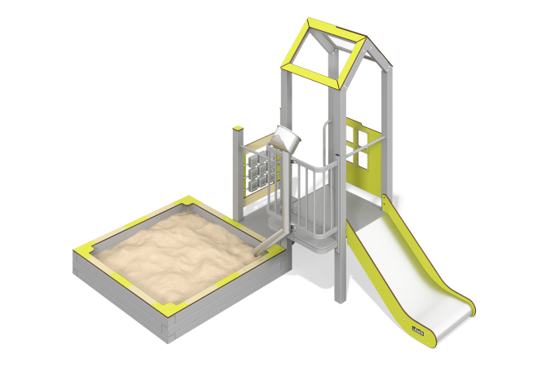

Size, mm: | 2216x3105x2333 | Weight, kg: | 402.6963
Material characteristics
Main Materials: Laminated plywood with anti-slip coating, HPL plastic, metal, stainless steel, solid polycarbonate, stainless steel fasteners.
Specification: Embedded parts – 1 set, support posts – 6 pcs, roof – 1 set, flooring – 1 set, sandbox – 1 pc, guard and decorative panels – 1 set, straight slide h=0.6m – 1 pc, balcony with sand chute – 1 pc, "Tic-Tac-Toe" play panel – 1 pc, climbing panel with foot grips – 1 pc, handles – 1 pc, handrails – 2 pcs, fastener kit – 1 set.
The design and color scheme of the equipment shall be as per the sketch.
The sand play area consists of one tower and an attached sandbox. The support posts are made of 80x80 mm metal profile. The house flooring is made of 18 mm thick laminated plywood with an anti-slip coating.
The roof is gable-type, constructed using a combination of HPL plastic frames and solid polycarbonate, which receives a colored coating applied via UV printing.
Decorative panels and play elements are made of 10 mm thick, double-sided HPL plastic with UV protection. Designs are applied to the panels and play elements using engraving and UV printing. The Tic-Tac-Toe game pieces are made of 100x100 mm glued laminated timber from softwood. The profile is square with a corner radius of R10. Metal overlays are made of 1.5 mm thick stainless steel.
The handles are made of metal tubing with a diameter of 26.8 mm and a wall thickness of 2.8 mm.
The house uses stainless steel fasteners. Protruding parts of threaded connections and open tube ends are covered with plastic caps.
The balcony is manufactured from 40x20 mm rectangular hollow section with a 2 mm wall thickness, and cross-tubes with a diameter of 21.3 mm and a 2.8 mm wall thickness. The metal crossbars are made of round tubing with a diameter of 21.3 mm and a 2.8 mm wall thickness. The sand chute is made of stainless steel: a 76 mm diameter tube with a 1 mm wall thickness and a 1.5 mm thick sheet.
Access to the platform with the slide is provided by a climbing panel with foot grips, made of 10 mm thick HPL plastic.
Surface Finishes:
Metal: zinc-rich primer, powder coating.

