14.034 |  | Carousel Eco
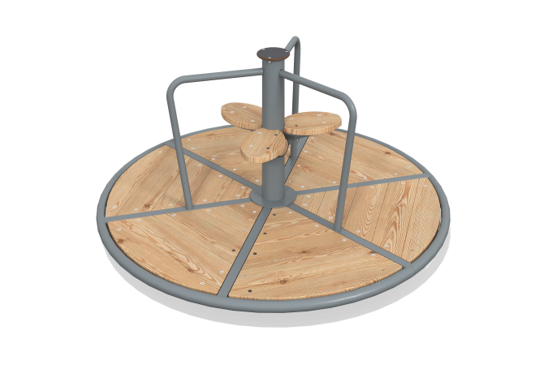

Size, mm: | 1660x1660x805 | Weight, kg: | 130.618
Material characteristics
Materials: moisture-resistant birch plywood, metal, acrylic paint, powder paint.
The central axis of the bearing assembly is made of a solid metal circle with a seat diameter of 45 mm, at the base of which there is a metal plate with rounded corners measuring 260 mm x 260 mm and a thickness of 10 mm.
The moving part of the carousel rotates on two angular contact roller bearings installed in a pipe with a diameter of 108 mm and a wall thickness of 3.5 mm. The frame of the moving part is entirely welded.
The outer ring of the floor frame frame has a diameter of 1660mm and is made of 33.5mm diameter metal round tube, and the six lintels and three support handles are made of 26.8mm diameter metal round tube.
On the central axis there are three seats made of high-strength, moisture-resistant birch plywood 21 mm thick. The surfaces are sanded, the edges are rounded, the treated surfaces are coated with two layers of tinted and colorless varnish.
The floor is made of moisture-resistant plywood 15 mm thick.
The embedded element consists of four L-shaped supports with rounded corners, made of a metal round pipe with a diameter of 26.8 mm, which in the upper part are welded to a counter plate measuring 260 mm x 260 mm and 10 mm thick, with holes for attaching the carousel.
All existing metal parts are coated with polyester powder paint. All fasteners are galvanized.
Contents: assembled carousel - 1 set.
to a depth of 0.5-0.6 m.

