34.125 |  | Horizontal outdoor table (set)
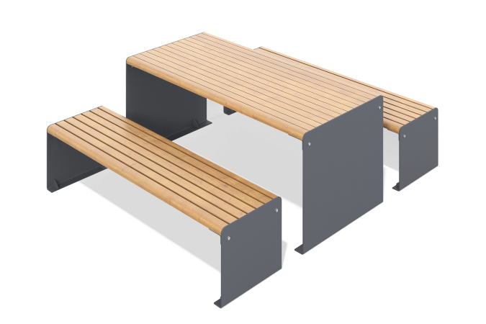

Size, mm: | 840x1800x450 | Weight, kg: | 0
Material characteristics
Materials: pine, metal
Set: table - 1 pc.
Wooden part: softwood (pine), treated with a special impregnation that reduces water absorption and provides protective functions (2 layers of yacht varnish with intermediate sanding)
Coating of elements:
- metal - zinc primer

