37.004 |  | Play System Science
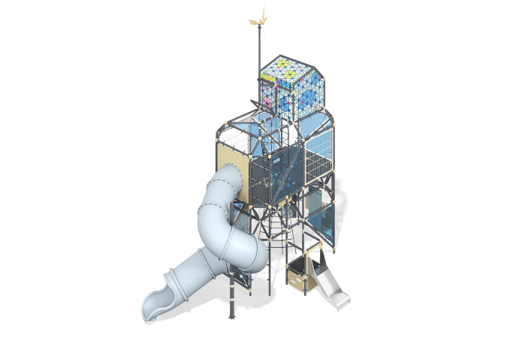

Size, mm: | 3890x6284x7833 | Weight, kg: | 2644
Material characteristics
Materials: metal, laminated plywood with anti-slip coating, HPL plastic, HDPE plastic, monolithic polycarbonate, reinforced polypropylene rope, stainless steel, stainless fasteners.
Contents: embedded parts - 1 set, frame rods - 184 pcs., transparent panel - 16 pcs., floors - 1 set, markhi unit - 79 pcs., straight slide - 1 pc., screw slide - 1 pc., panels with slots for legs - 8 pcs., balancing game "Billiards" - 1 pc., balancing game "Gate" - 1 pc., metal mesh - 2 pcs., mesh - 2 pcs., game element "Calendar" - 1 set, panel with chips - 1 set, wind generator - 1 set, fastening kit - 1 pc.
Design and color palette of equipment according to the sketch.
The gaming complex consists of 2 floors, which are connected by a rope ladder. The frame of the complex consists of conventional parallelepipeds with cut corners, the faces of which are metal rods.
The rods of the complex are made of a metal round pipe with a diameter of 57 mm and a wall thickness of 3 mm. The frame is connected using galvanized Markhi nodes. The modules are connected by rope manholes made of six-strand reinforced polypropylene rope d=16 mm. The glazing of the complex is made of monolithic polycarbonate 10 mm thick, onto which color coating and patterns are applied using UV printing. On the second floor of the complex, mesh fencing is made of metal mesh on a frame made of 40x20 profile pipe with a wall thickness of 2 mm.
The entrances of the complex are designed in the form of a rope ladder, rope mesh, free areas between frame elements, and HPL panels with slots for legs. The floors are made of 15 mm thick laminated plywood with an anti-slip coating.
The complex includes one straight stainless steel slide and a plastic tunnel screw slide. The open straight slide h=560 mm is made entirely of stainless steel. It consists of a slope and sides made of stainless steel sheet 1.5 mm thick. The handrail of the slide is made of a round stainless steel pipe with a diameter of 26.9 mm and a wall thickness of 2 mm. The staircase that leads to the slide and to the 2nd floor is made of 10 mm thick HPL plastic, with grooves for the feet cut out inside it.
The developmental elements of the complex - stadiometer, calendar, labyrinth, panel with chips - are made on panels made of HPL plastic 10 mm thick. The complex also includes the balancing game “Billiards” and the balancing game “Gate”. The base of the modules is made of HPL plastic, the fencing is made of stainless steel, the cover is made of transparent polycarbonate. The educational element “Billiards” is a game panel with holes and balls that need to be rolled into the holes. The educational element “Gate” is a game panel with stainless steel “gates” with numbers printed on them, and a ball that needs to be rolled into the gate to earn points.
The “Windmill” element is a model of a wind generator. The gaming installation on the second floor of the complex allows you to measure the voltage, strength and current power generated by a wind turbine installed on the roof of the complex. The windmill stand is made of a round metal pipe with a diameter of 57 mm and a wall thickness of 4 mm. A windmill with 5 blades is installed at the top of the rack. At the bottom, the stand ends with a steering wheel made of a round pipe with a diameter of 108 mm with a wall thickness of 3 mm with handles made of a pipe with a diameter of 33.5 mm. A panel made of HPL plastic with windows in which data is displayed is installed on the steering wheel frame.
The complex uses stainless steel fasteners. Protruding parts of threaded connections and open parts of pipes are closed with plastic plugs.
Element coverage:
- metal - powder zinc primer, powder paint.

