17.042 |  | Swing Urban
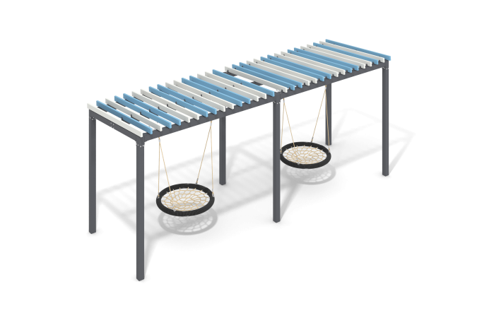

Size, mm: | 1980x6030x2514 | Weight, kg: | 551.89904
Material characteristics
General description of the design
The product is a set of a frame with a slatted two-color canopy for a swing and two “nest” pendants with rope weaving.
Materials and components
Powder-painted steel with a layer of zinc-containing primer, wooden boards and (or) WPC, stainless steel fasteners. The swing includes two “nest” suspensions with a weighted rim. The diameter of the suspension is 1000 mm. The weaving inside the ring is made of four-strand rope with a diameter of 16 mm. The diameter of the rim after braiding with rope is 1100 mm. The swing is equipped with suspensions made of four-strand reinforced rope. The swing is designed for intensive use, can withstand a load of up to 250 kg - suitable for playgrounds in public places (parks, squares, local areas).
Metal parts are coated in two layers: as the first layer, a powder zinc-containing primer is applied, which is a powder mixture based on epoxy resin, zinc and targeted additives, and polymerized in a high-temperature chamber. As a finishing layer, polyester powder paint is applied, which is a homogenized powder mixture of polyester resin, hardeners, pigments, fillers and modifiers selected to ensure weather resistance and light resistance. The finishing layer is polymerized in a high-temperature chamber.
Frame
It consists of metal profile pipes as pillars, connected at the top by crossbars, to which a slatted canopy and swing hangers are attached. The supports are made of 100x100 profile pipes with a wall thickness of 3 mm.

