17.045 |  | Swing Arc
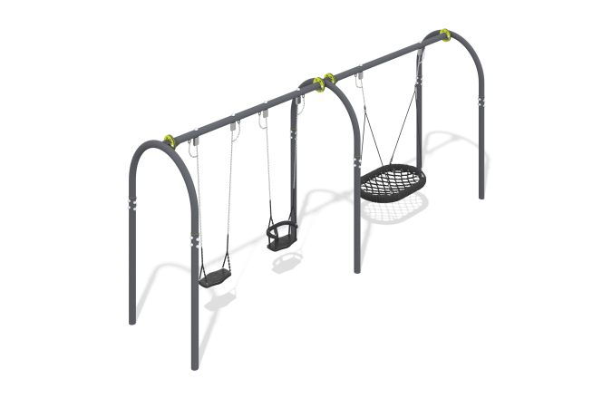

Size, mm: | 1300x5985x2465 | Weight, kg: | 240.279
Material characteristics
General description of the design
The product is a set of U-shaped frames with crossbars, a suspension with rope weaving and two suspensions on chains.
Materials and components
Powder-painted steel with a layer of zinc-containing primer, polypropylene reinforced rope, stainless steel fasteners.
The metal is painted with anthracite gray polymer paint.
The swing includes a “nest” suspension with a weighted rim. The diameter of the suspension is 1045 mm.
The weaving inside the ring is made of four-strand reinforced rope with a diameter of 16 mm.
The swing is equipped with suspensions made of four-strand reinforced rope.
The swing is designed for intensive use, can withstand loads of up to 250 kg - suitable for playgrounds in public places
(parks, squares, local areas).
Metal parts are coated in two layers: a zinc-containing powder primer is applied as the first layer,
which is a powder mixture based on epoxy resin, zinc and targeted additives, is polymerized in a high-temperature chamber.
As a finishing layer, polyester powder paint is applied, which is a homogenized powder mixture of polyester resin,
hardeners, pigments, fillers and modifiers selected to provide weather resistance and light resistance.
The finishing layer is polymerized in a high-temperature chamber.
Frame
The frame consists of three supports, each of which is made of metal pipes and two crossbars fixed between them,
made from round pipe 89x3mm.

