13.192 |  | Play System Towers
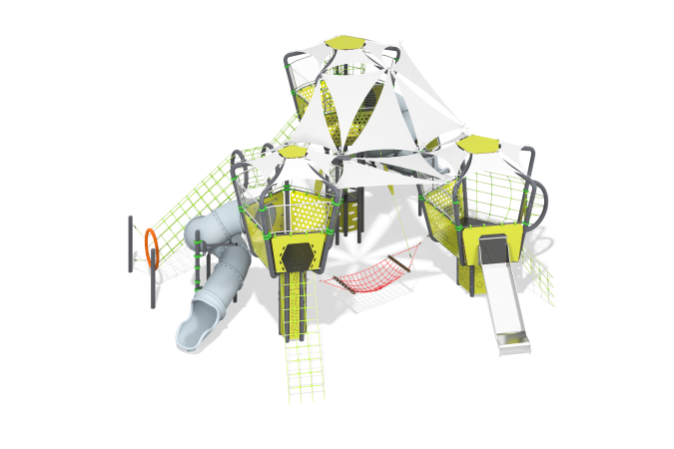

Size, mm: | 11496x12757x5440 | Weight, kg: | 2890.72
Material characteristics
Materials: metal, stainless steel, HPL plastic, laminated plywood, monolithic polycarbonate, rope with a steel core, LDPE plastic

