16.053 |  | Spring Rider Antelope
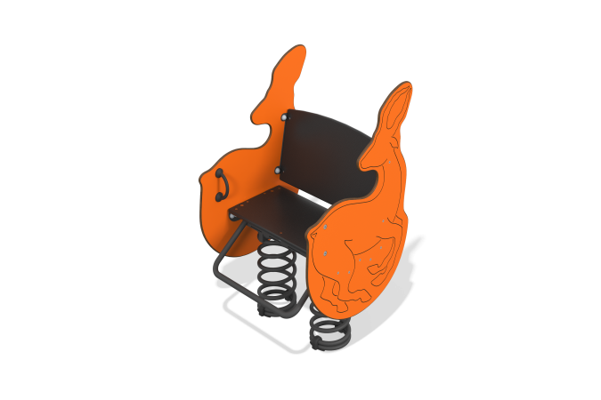

Size, mm: | 748x763x1200 | Weight, kg: | 45.46
Material characteristics
Materials: metal, HPL plastic, laminated plywood.
General description of the design
The product is a rocking chair on a metal spring, where the walls are made of HPL plastic decorated with the shape and milling of an antelope.
Materials and components
Powder-painted steel with a layer of zinc-containing primer, 10 mm thick HPL plastic, laminated waterproof plywood, stainless fasteners.
Metal parts are coated in two layers: as the first layer, a powder zinc-containing primer is applied, which is a powder mixture based on epoxy resin, zinc and targeted additives, and polymerized in a high-temperature chamber. As a finishing layer, polyester powder paint is applied, which is a homogenized powder mixture of polyester resin, hardeners, pigments, fillers and modifiers selected to ensure weather resistance and light resistance. The finishing layer is polymerized in a high-temperature chamber.
The frame consists of the metal base of the rocking chair (platform-springs-platform), as well as straight and bent round metal pipes that determine the basic shape of the rocking chair.
The seat is made of high-strength, moisture-resistant laminated plywood 15 mm thick, lined with phenolic or melamine film 120-220 g/m2, with a signature “hexagonal structure” pattern.
The side walls are made of HPL plastic with a thickness of at least 10 mm. All edges are rounded using special knives or milling.
Installed on two end compression springs. The spring is fastened to the support platform using U-shaped clamps.

