11.020 |  | Seesaw Discovery
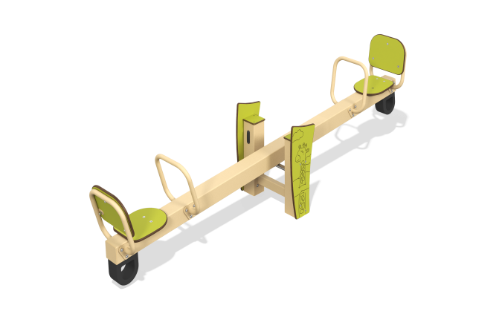

Size, mm: | 498x2652x676 | Weight, kg: | 63.95
Material characteristics
General description of the design
The product is a balancer with handles and seats, pivotally connected to a pipe mounted on two metal posts made of a profile pipe. In the center of the balancer canvas there are panels with stylized images of animal tracks.
Materials and components
Powder-painted structural steel with a layer of zinc-containing primer, HPL plastic, stainless steel fasteners. The level is made of translucent polycarbonate and liquid. The handles are made of metal round pipe DN20 with a diameter of 26.8 mm and a wall thickness of 2.8 mm. The main beam is made of a 100x100 profile pipe with a wall thickness of 3 mm.
The maximum angle of inclination of the seat is no more than 20°. Damping is used to prevent sudden stops. The height difference in the extreme positions of the balancer crossbar is no more than 1000 mm. The base of the balancer is made of a 100x100mm profile pipe with a wall thickness of 3 mm. The support unit of the balancer crossbar is made of two bearing supports and a movable axis. The moving part of the support unit rotates in two radial bearings installed in bushings. The protruding metal parts of the metal profiles are covered with plastic plugs.
The frame is a metal base of two pillars made of a 100x100 mm profile pipe with a wall thickness of 3 mm, connected to the working part of the balancer through a hinge with one rotational degree of freedom.

