39.050 |  | Waste container enclosure (4 containers)
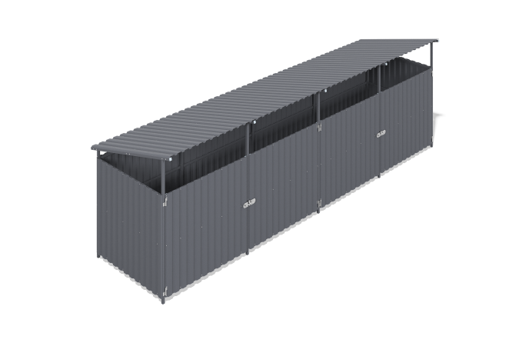

Size, mm: | 1960x6500x2200 | Weight, kg: | 229.58
Material characteristics
Materials: metal.
Complete set: side sections - 2 pcs, intermediate sections - 3 pcs, frame cross-members - 24 pcs, welded doors - 4 pcs, embedded parts - 10 pcs, profiled sheet 1500 mm long - 17 pcs, profiled sheet 2000 mm long - 7 pcs.
Four-section container platform with doors is designed for container placement and protection from rain and other weather conditions. The frame is constructed from welded panels, cross-members and doors made of 40x40 mm and 40x20 mm profile steel tube with 2 mm wall thickness, complemented by flanges and plastic components. All metal components undergo shot blasting, cleaning, degreasing and powder coating. The cladding is made of galvanized C20 profiled sheet with polymer coating, fixed with self-drilling roofing screws with sealing washers.

