33.009 |  | Information board with pockets
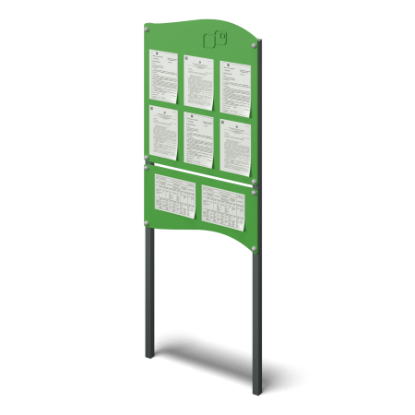

Size, mm: | 94x800x2100 | Weight, kg: | 16.5
Material characteristics
Materials: plywood, metal.
The product consists of upper and lower shields mounted on racks. The boards are made of 15 mm plywood, the racks are made of metal profile pipe with a cross section of 60 mm x 40 mm x 2 mm. Metal and plywood are painted with polymer paint.
All open parts of pipes and bolted connections are closed with plastic plugs of the appropriate size.
Contents: racks – 2 pcs., upper shield with pockets – 1 pc., lower shield – 1 pc., fastening kit – 1 pc.

