RPS-18502 |  | Fitness equipment exercise RPS-18502
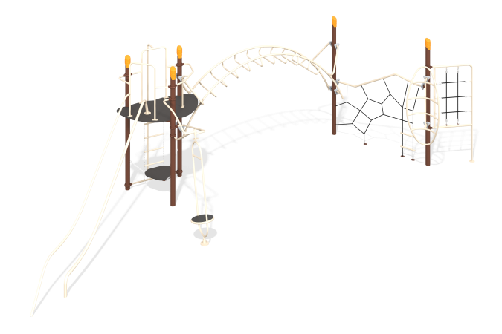

Size, mm: | 3900x11100x3500 | Weight, kg: | 0
Material characteristics
Material:
Post: Galvanized pipe
Guardrail and handrail parts: Galvanized pipe.
Clamp, base, Post Cap: Aluminum Alloy.
Hardware Screws: 304 Stainless Steel, anti-theft screws.

