25.049 |  | Geoplastics Rings
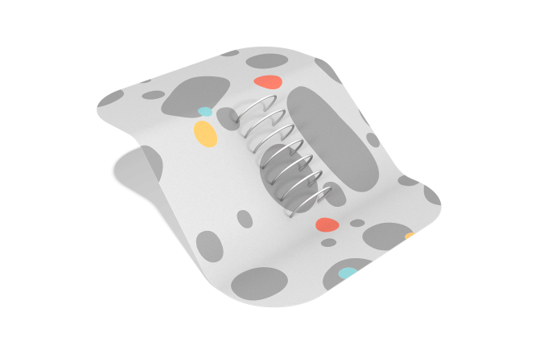

Size, mm: | 900x1876x1678 | Weight, kg: | 31.8
Material characteristics
Materials: Stainless Steel.
Specifications:
Geoplastic Ring: 7 units
Mounting Hardware Set: 1 set
Anchor Flange / Base Plate: 7 units
Note: All fasteners are made of stainless steel.

