23.026 |  | Educational Module Glockenspiel
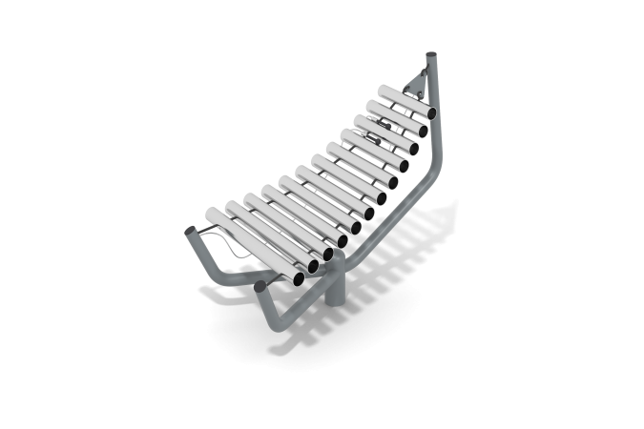

Size, mm: | 500x1200x750 | Weight, kg: | 27
Material characteristics
Materials: metal, powder paint, stainless steel.
The central stand of the metallophone is made of a metal pipe with a diameter
108 mm with arcs made of metal pipe with a diameter of 42.3 mm.
Tubes for sound extraction (10 pcs). made of stainless steel pipe with a diameter of 57 mm. Minimum length 275 mm – maximum length -500 mm.
The tubes are fixed on a steel cable with a diameter of 5 mm.
All metal elements of the body are cleaned, degreased and coated with polyester powder paint.
Equipment:
Metallophone assembly – 1 set.

