13.175 |  | Play System Portal: Cube
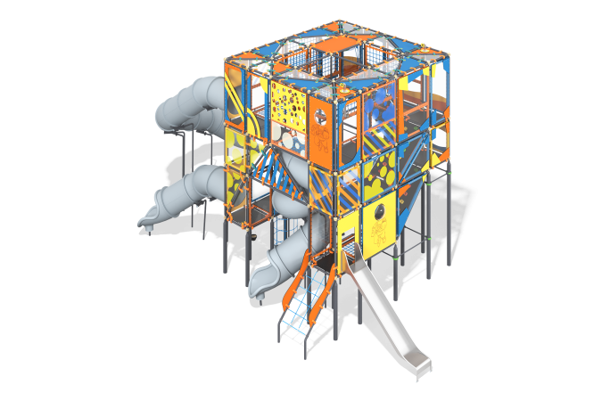

Size, mm: | 6710x12477x5929 | Weight, kg: | 842.8554
Material characteristics
Materials: metal, stainless steel, HPL plastic, laminated plywood, monolithic polycarbonate, rope with a steel core, LDPE plastic
General Structure Description
The concept of the playground complex is based on the idea of high-density integration of various physical (slides, climbing panels, rope nets) and mental (light filter games, tic-tac-toe, etc.) activities within the specified space. The framework of the complex comprises metal pipes and connectors, forming a trajectory resembling a spiral staircase, constructed from rope ladders and transitions. The entrance to the complex is designed as an inclined panel of sheet material and rope nets with railings. The complex includes four slides: one open and three tunnel slides.
Materials and Components
Powder-coated steel with a zinc-based primer, 10 mm HPL panels, water-resistant laminated plywood, polypropylene six-strand reinforced rope, stainless steel fastenings.
Metal components undergo a two-layer coating process, consisting of a zinc-based powdered primer as the first layer, followed by a polyester powder paint layer to ensure weather and light resistance. Special plastic end caps and composite fastening caps, stainless steel fastenings, and adjustable mounts for the swings are used as components in the structure. The frame is constructed from 108 mm diameter steel pipes with 3 mm wall thickness, 89 mm diameter pipes with 3 mm wall thickness, 57 mm diameter pipes with 3 mm wall thickness, and additional frame components are made from 33.5 mm diameter pipes with 2.8 mm wall thickness. Special load-bearing ball-joint node connections, decorative elements, and all metal framework elements are coated with a waterproof zinc-based primer before being powder coated.
As parts of the structure, the components include plastic end caps for pipe ends, plastic composite caps for fastenings, stainless steel fastenings, special attachments for swing suspension, and stainless steel chain.
The frame consists of steel pipes with a diameter of 108 mm and a wall thickness of 3 mm, pipes with a diameter of 89 mm and a wall thickness of 3 mm, and pipes with a diameter of 57 mm and a wall thickness of 3 mm. Additional frame elements are made from pipes with a diameter of 33.5 mm and a wall thickness of 2.8 mm. Special load-bearing spherical node connections, made from quality carbon steel grade 45 according to GOST 1050-88, and decorative elements are used to connect the pipes. All metal frame elements are coated with a zinc-based primer before being powder-coated. All metal components undergo cleaning, degreasing, and shot blasting processes before the application of coatings.
The fillings and enclosures consist of durable, moisture-resistant, UV-resistant 10mm HPL plastic for decorative, structural, and play panels. The rope nets are made from UV-resistant 16mm diameter polypropylene six-strand reinforced rope with connections made from durable plastic and/or specialized stainless steel or aluminum fasteners. All edges of the HPL sheet plastic components are treated and smoothed using special edge trimming knives or milling. The platform floors are made from laminated plywood.
Slides: The complex includes four plastic slides: one open and three tunnel slides. The lower part of the tunnel slides has a straight, open "braking" section.
Nets: The complex includes ladders and "nets" made from reinforced polypropylene rope with a 16mm diameter, consisting of six strands, each reinforced with eight metal wires. The steel wires are coated with twisted polypropylene split (braided polyester).
Interactive Elements: The complex includes special developments - interactive elements, exhibits, educational stands, and game modules.

