17.119 |  | Illuminated round seat
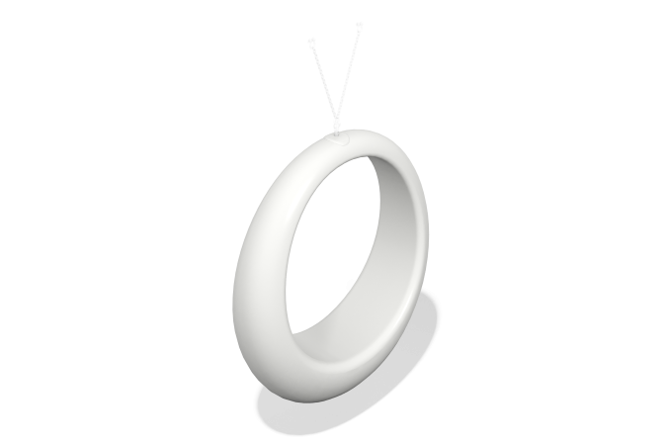

Size, mm: | 450x1500x1500 | Weight, kg: | 23
Material characteristics
Materials: plastic
Package includes: Round pendant with backlight – 1 pc.
The product is designed for aesthetic improvement of parks and urban public spaces. Color: white, translucent, light-transmitting. The product is made of 3D plastic: linear low-density polyethylene for rotational molding, which does not fade and does not deteriorate under the influence of sunlight. Surface type: shagreen. Operating temperature ranges from -60 to +60 degrees Celsius. The fastening mechanism is a swivel with a rigging bracket, with a current collector, sliding contact and a cable inserted inside, the cable is heat- and frost-resistant, cross-section 2x0.75. External dimensions of the product: diameter 150 cm, width 45 cm. Wall thickness 5 mm, the product is hollow inside. The product is supplied with chains for subsequent hanging on the pergola. An IP44 light element is installed inside the product, which is a mounted addressable RGB LED strip along the inner circumference of the product; the product is supplied with an external power supply for connection to 220 V.

